**ACTIVITY-I**

**AWARENESS ON DIGITALIZATION**

**ACTIVITY DETAILS**

|  |  |  |
| --- | --- | --- |
| **Activity Category Head** | **:** | Awareness on Digitalization |
| **Total Duration Spent** | **:** | 80 hours |
| **Activity Place** | **:** | Mysore |

ABSTRACT

In digital India campaign, Indian government has stressed on speedy and substantive reforms in digitalization for promotion of quality and excellence. Digital Payment is one of these reforms. There are so many awareness programmes have been started to spread Awareness regarding various modes of Digital Payment like Digi Shala-Educational TV channel for digital payments, Digital finance for rural India creating awareness and access through common service centres, Vittiya Nakshatra Abhiyan (Vaisaka) by MHRD. As Digital Payment is still in its infancy stage and general public being is an important part of the system, it is essential to understand their perspective and to know how much they are aware about this system. Here it is interested to examine particularly about the Awareness level of Digital Payments among people in the present Indian setting due to the intriguing developments that are currently taking place. It provides insights which will lead to wider Digital Payments Acceptance of and use, to the extent that Digital Payments ultimately becomes a preferred medium for economic transactions in India. In this chapter the focus is given to check Awareness regarding functioning of various modes of Digital Payment.

# JUSTIFICATION FOR CHOOSING THIS ACTIVITY

The Digital India is the Indian Government flagship programmed with a vision to convert India into a digitally empowered country. Faceless, Paperless, Cashless is one of supposed function of Digital India. as part of government reforms Prime Minister Mr. Narender Modi demonetized the high value currency of Rs.500 and 1000 in November 2016 and also launched the digital India initiative in 2015.These initiatives have provided extensive boost up to the digital payment system in the country. Government other initiatives like BHIM and UPI are supporting in transition and faster adoption of digital payments. Electronics Consumer transaction made at point of sale for services and products either through internet banking or mobile banking using smart phone or card payment are called as digital payment. The digital payment system has the following phases,

1. Registration
2. Invoicing
3. Payment selection
4. Payment confirmation.

This payment system generally includes 3 electronic payment instruments namely, cash, cheque and card. Post demonetization is affecting the e-commerce sector that Cash on Delivery is gradually getting stopped and other modes of payment is replaced like Card on Delivery, Net Banking, Debit Card, Credit Card etc. Demonetization will positively help out e-commerce industry in India enhances the chance for people to go cashless. As part of encouraging cashless transactions and transforming India into society, various modes of digital payments are available. The demonetization resulted in tremendous growth in digital payments. With the government initiative such as Digital India and increased use of mobile and internet are means to exponential growth in use of digital payment. This transformation towards digital payments benefits in more transparency in transactions which empowers the country’s economy.

Due to these reasons, I wanted to spread awareness among the public about the digitalization.

# PLANNING AND APPROACH

The study is conducted to obtain data on adoption of digital payment system in India. The study is conducted in Hyderabad region. A sample size of 200 was selected using the convenience sampling. Out of which 183 were responded. This represents a response rate of 92%. Structured questionnaires are used for collecting data. The responses from the respondents were an using the simple percentage analysis and Chi square test because two passwords required for verification. As network signals are not available, then locker may not be opened. Digital payment awareness was created by the following train the trainer model in the district.

The research was carried based on primary and secondary data. The primary data for research objectives was collected from the samples based in Hyderabad city only. Though Hyderabad is one of the most significant cities of the country and a commercial hub of south India, with only 183 samples selected from the city cannot be considered as a complete representation of the population of the country. However, the objective of the survey was to verify the customers perceptions on digital payments with regard to the concept of general banking. Thus, this may not create obstruction in achieving the desired objective even if Hyderabad city cannot replicate other major banking hubs of the country. For primary data, nonresponse error cannot be ruled out. The study examines the effect of adopting digital payments impact on consumers of the banking sector of India. The result put together gives us an important policy direction towards what can enable the country to increase cashless payments The results indicate that the deployment of technology for digital payments have improved the performance of banking sector and able to achieve the motive cash less country. The study gives emphasis to the percentage of awareness on maximum utilization of technology. Banks should take effective measures in creating awareness towards the effective usage of technology and security

# WORK DONE

**Day 1:** Informing the rural people about the importance and user friendliness of online banking

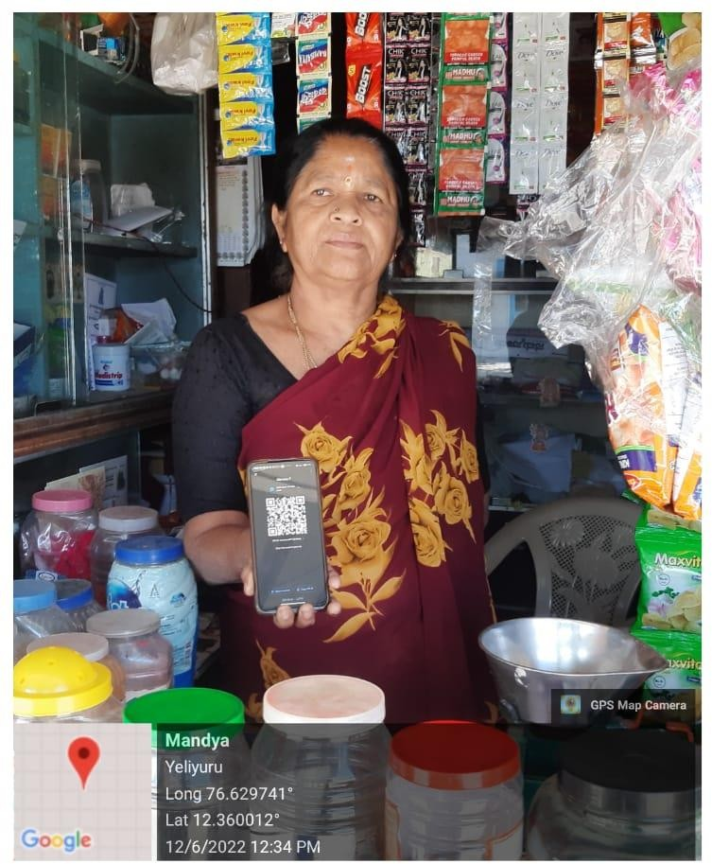

**Fig1:** conducting awareness camps in rural areas to educate people about digital banking Operations

Mobile Banking means use of smartphone to perfume online transitions easier and faster way. Almost all the banks who having good branch network in the country are providing Mobile Banking facilities to its customer. According to RBI annual report 2017-18, Mobile banking services grown to 92% and 13% in volume.

With the help of Aadhaar Enabled Payment System (AEPS) people can carry out transaction with the help of 12-digit number without having bank account number with the help of this service people can get the facilities like withdraw/deposit cash, balance transfer, fund transfer and mini statement with authentication of biometric. sample of 100 respondents to analysis of customer perception and out of the sample 95% respondents were using electronic banking services.

## **Day2:** Linking mobile number to bank account

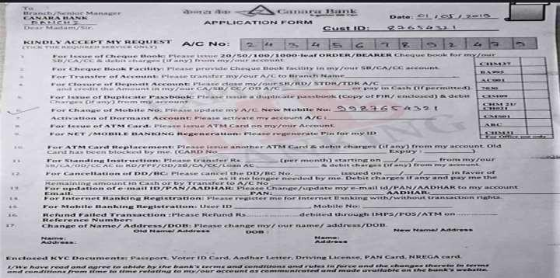

**Fig2:** Mobile number Register form

Linking your mobile number to your bank account is an important step that can help you manage your finances more efficiently and securely. Fraud prevention: By linking your mobile number to your bank account, you can receive instant alerts about any unauthorized transactions or suspicious activity on youraccount. This can help you take immediate action to prevent fraud or identity theft. When you link yourmobile number to your bank account, you can use mobile banking services to access your account information, make transactions, and check your balance from anywhere, at any time. This can be especially helpful if you are traveling or don't have access to a computer Many banks offer mobile banking services that allow you to transfer funds, pay bills, and make purchases using your mobile phone. This can save you time and make it easier to manage your finances on the go. Your bank may use your mobile number to send you important updates, such as changes to your account terms or new products and services. By keeping your contact information up to date, you can stay informed about your account and make sure you don't miss any important information. Overall, linking your mobile number to your bank account can help you stay on top of your finances, protect yourself from fraud, and make banking more convenient and accessible.

**Day 3:** Install the application

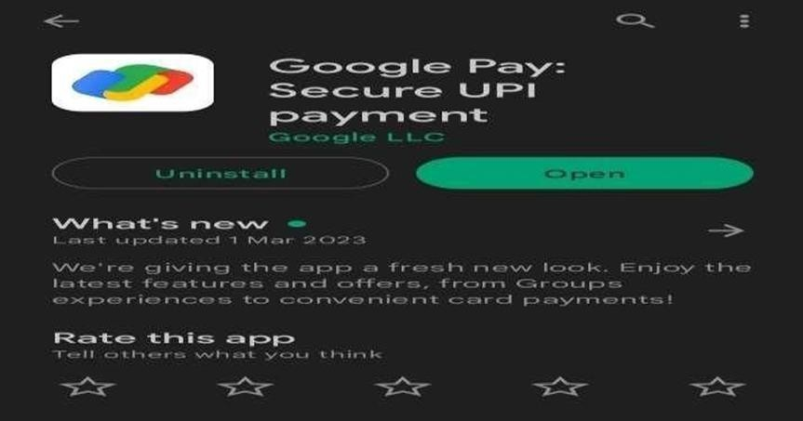

**Fig:** Installation of app provide an introduction to an online payment app that can be us Useful to

rural people

An online payment app is a mobile application that allows users to transfer money electronically from one account to another. It can also be used to pay bills, purchase goods and services, and make donations. The main advantage of using an online payment app is that it eliminates the need for cash and reduces the risk of theft.

For rural people, an online payment app can be especially beneficial because it can provide access to financial services that may not be available locally. With an online payment app, rural people can easily transfer money to friends and family, pay for goods and services, and even receive payments for their own products or services.

When choosing an online payment app, it's important to look for one that is secure, easy to use, and widely accepted. Some popular online payment apps include PayPal, Venmo, Google Pay, and Apple Pay.

Overall, an online payment app can be a convenient and secure way for rural people to access financial services and manage their money.

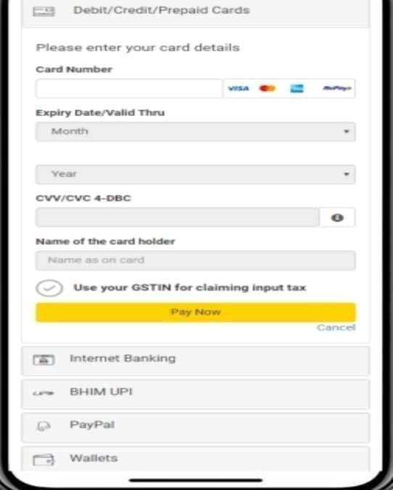

**Fig**: Create an account by providing your name, email address, and phone number,ATM card details and generate UPI.

## **Day 4:** Conduct hands-on training session

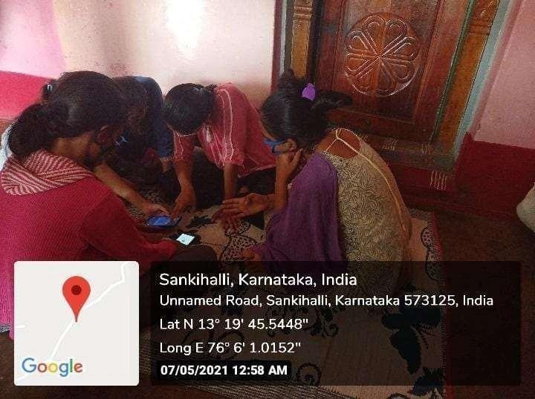

**Fig:** Conduct hands on training session and make small groups, so people can ask Question and

clarify their doubts.

Conducting hands-on training sessions in banking awareness for rural people is an important step in promoting financial inclusion and increasing financial literacy. Here are some tips to help you plan and conduct an effective training session Before you begin planning your training session,it's important to understand the needs and interests of your audience

Choose your topic: Depending on the needs of your audience, you may want to focus on topics such as basic banking services, types of accounts, digital banking services, and how to save money. Choose a topic that is relevant and useful to your audience.

conducting hands-on training sessions in banking awareness for rural people can be a rewarding experience that helps promote financial literacy and inclusion.

**Day 5:** Offer incentives to encourage people to use digital banking services.

Offering incentives in online bank transactions can be an effective way to encourage customers to use online banking services and promote digital banking adoption. Here are some examples of incentives that banks can offer:

Cash back rewards Banks can offer cash back rewards for customers who use online banking services to make payments, transfer money, or pay bills. For example, a bank might offer a 5% cash back reward for customers who use online banking to pay their monthly bills.

Discounts on fees Banks can offer discounts on fees for customers who use online banking services. For example, a bank might waive the fee for transferring money online or for using a specific digital payment platform.

Bonus interest rates Banks can offer bonus interest rates for customers who use online banking services to deposit money into their savings accounts or certificates of deposit (CDs). For example, a bank might offer an additional 0.25% interest rate for customers who use online banking to deposit money into their savings account.

Loyalty rewards Banks can offer loyalty rewards for customers who regularly use online banking services. For example, a bank might offer bonus points for customers who use online banking to make purchases using their credit card.

By offering incentives in online bank transactions, banks can encourage customers to adopt digital banking services, which can save time and provide added convenience. In addition, offering incentives can help banks attract new customers and retain existing ones.

## **Day 6**: Creating awareness about Bank policies



**Fig6:** Fill in the Bank policies Application

Creating awareness about bank policies in online banking is crucial to help rural people understand their rights and responsibilities as bank customers in the digital age. Here are some key points to explain to rural people about bank policies in online banking:

Terms and conditions: When signing up for online banking, rural people should be provided with a copy of the bank's terms and conditions for online services. These documents outline the rules and regulations that govern the bank's online services, including security measures, fees, and policies for online transactions.

Online disclosures: Banks are required by law to provide certain disclosures to customers in online banking, such as information about fees, interest rates, and terms and conditions. Rural people should bead vised to carefully review these disclosures before using online banking service.

# OUTCOME OF THE ACTIVITY

Online banking allows rural people to access their bank accounts and conduct transactions from anywhere with an internet connection. This can be particularly helpful for people who live far from a bank branchor have limited transportation options. people with a better understanding of their finances by allowing them to view account balances, transaction histories, and other financial information in real- time. This can help rural people make informed decisions about their money and plan for the future.

rural people time by allowing them to conduct transactions quickly and easily from their computer or mobile device. This can be especially beneficial for people who work long hours or have busy schedules.In summary, online bank transactions can provide several positive outcomes for rural people, including convenience, time-saving, cost-saving, security, and improved financial management. By using online banking services, rural people.